Title: Assignment #1

Spotify data management system

Course:

CST2355

Section #: 302

Group #: 2

Group Members:

Member #1: Lei Zhao 041086365

Member #2: Tianjiao Feng 041086011

Member #3: Vitor Curado 041090973

# Database ERD Model

# Installation and Backup Instructions

## Backup instructions

* Go to SQL Server Management Studio (SSMS) and right-click the database name which needs to be backed up.

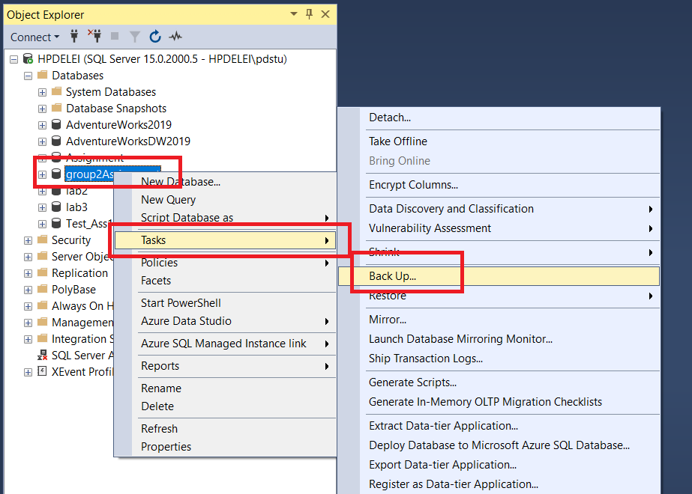

* Go to Task and then click the Backup button; the following window will pop out:

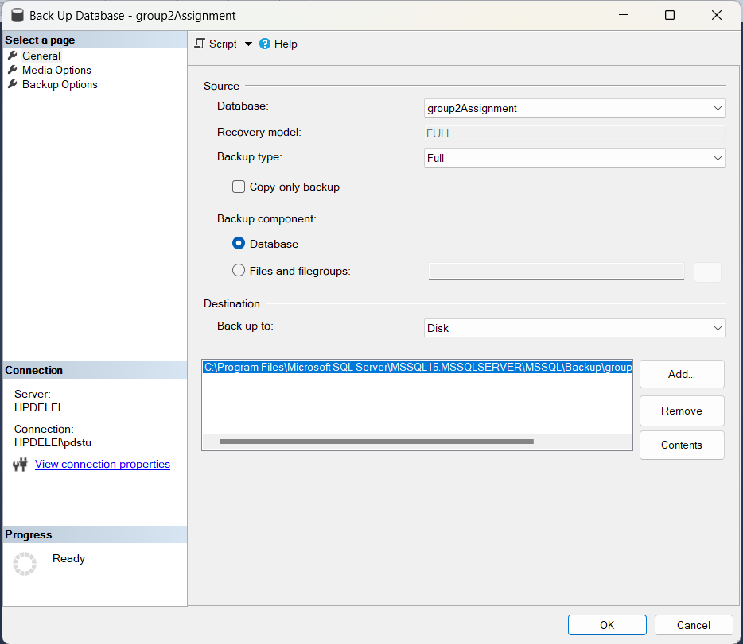

* To obtain the address where the backup file is stored, click the add button and copy the address from the popped-out window, then click the Cancel button to get back to the Backup window.

* Click OK to complete the backup.
* Go to windows explorer and paste the address in the address bar; the Explorer will redirect to the folder where the backup file is stored. For Group 2, the name of the backup is group2Assignment.

## Database restore instructions

When loading the backup file into the computer, put it in the SSMS backup folder. (To obtain the folder address, please read the Backup instructions.)

Once connected to the SSMS server, right-click the Database label in the Object Explorer on the left of the SSMS window.

Click on Restore Database, then on Device, explore the folders and files by clicking on the three dots, and find the backup file in the backup folder.

Give the Destination Database a name, such as group2Assignment, and click OK, then the backup will be restored.

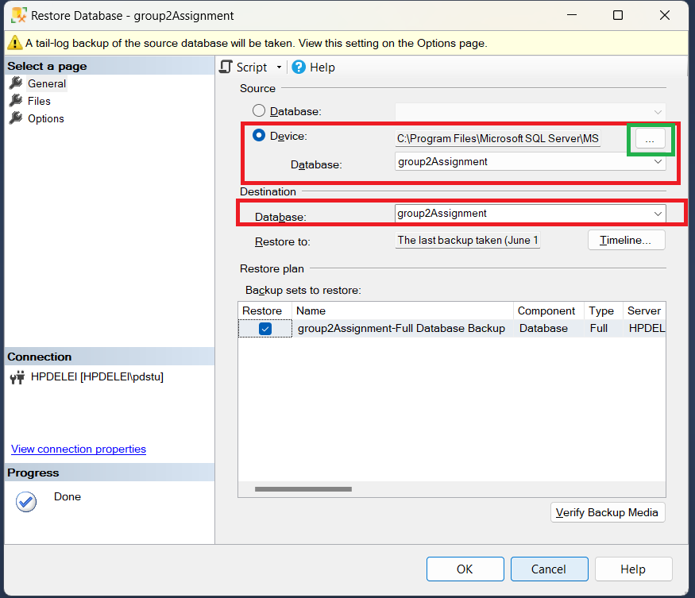

## Create login information:

* Go to the Objects Explorer on left of the SSMS window, right click on New then Login.
* Enter the Login name “group2User” and then click on the SQL Server authentication option.
* Enter the password “group2User” and uncheck “Enforce password policy” and the two following options will be unchecked automatically.
* Change the default database to the one just restored, which is “gourp2Assignment”.

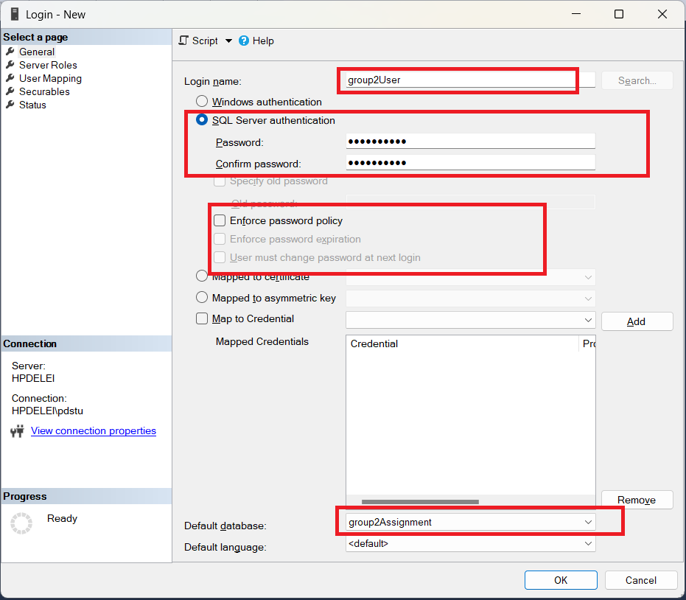

* Open a new query window and execute the following commands:

USE group2Assignment;

EXEC sp_changedbowner 'group2User', 'true';

Then the login information is done.

## Create ODBC connection

* Type ODBC in windows search bar, the click ODBC Data Source (64 bits).
* Click on Add in the pop out window, select the driver SQL Server Native Client RDA 11.0 and click on finish.
* Enter the connection name group2User, and the server’s name of the host computer and click Next.

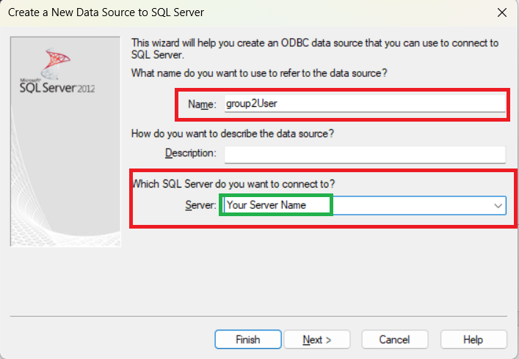

* To obtain the server’s name, go to SSMS and check the name of the root directory in the Objects Explorer.
* Choose the SQL Server Authentication and use the login ID “group2User” and password “group2User”, click on next.

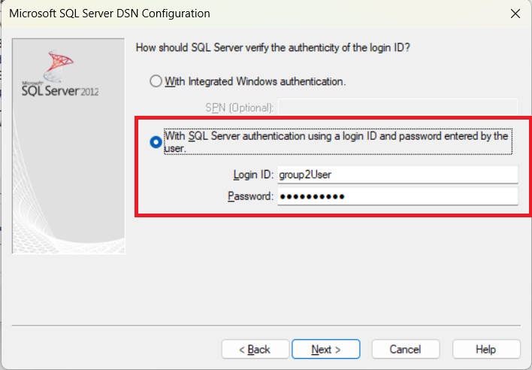

* Keep all the default settings until finish the setup is done, a test window will pop out.
* Click on test, and if the settings are all good, it will show that the connection is successful.

## Access application restore:

Put the Access file wherever as user prefers on the host computer and double click on it. A SQL Server login window will pop out while the application is opening, use the login ID and password given, which are both “group2User”, then the landing form will pop out and the installation of Access application is completed.

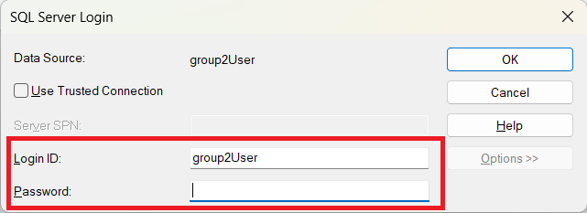

# Application Description

It is a simple management system capable of storing Spotify data. The system has dedicated forms for different categories, including artists, songs, playlists, users, and song genres. Users can locate songs by the track name, artist name, or even based on their popularity and danceability metrics. This makes the exploration of music a more interesting experience. The application consists of a Microsoft access used as an interface connected to a SQL Server using ODBC as a middleware. It enhances user engagement by offering various reports displaying a broader data view. These reports offer users valuable insights into their music habits, preferences, and trends.

Microsoft access is the interface. It has the raw tables linked from SQL Server database containing the data, but it also has custom-built forms, queries, and reports for the end-user to properly analyse Spotify data they may encounter. The Open Database Connectivity, O.D.B.C., interface is essential to this application as it is responsible for connecting the back-end piece to the front-end interactive interface. SQL Server is the DBMS itself as well as the database; it has the data and constraints.

The main chunk of information consists of song data; danceability, valence, tempo, duration, valence, danceability, each is used by Spotify to accurately categorize their songs into groups. The songs are the core part of this application, most, if not all other tables of information lead to songs. Songs may have one, or multiple genres. The same song may be on zero, one, or many distinct playlists. Songs must have at least one author, but many times, songs are produced by a collaboration of artists. Sometimes, the song was made by an orchestra, or a single music producer.

# User Instructions

Front-end users are the individuals interacting directly with Microsoft access. They are responsible for handling data using forms, queries, and so forth. Back-end users are typically developers, system administrators, and they are responsible for maintaining the server and database of this application.

## Front-end Users

As a front-end user, you'll primarily interact with the user interface and experience of the Microsoft Access application. Your responsibilities revolve around utilizing the provided features and functionalities to perform various tasks, such as data entry, querying and retrieving information, generating reports, and visualizing data through intuitive forms and reports. You'll navigate through the user-friendly interface, input and manipulate data, and interact with the application's features designed to streamline your workflow and enhance productivity.

### Landing Page

This is the landing page of the application. When opening the Access file, a login with a password will be required, please use the given password “group2User” to login. Once logged in, you will see the form frmSearchByUser. On top of the popped-out window, you can enter your username and search for playlist. Below the search bar, the playlists are displayed individually. On the left, it is the detail of the playlist. Your user ID, name, playlist name and the status of the playlist are shown. You can navigate your other playlist by the Previous and Next buttons. On the right side of the screen, you can check all the songs in the playlist shown left. On bottom of the page, there is also a small section created by the system with which you can also navigate the form, using previous, next and search functions.

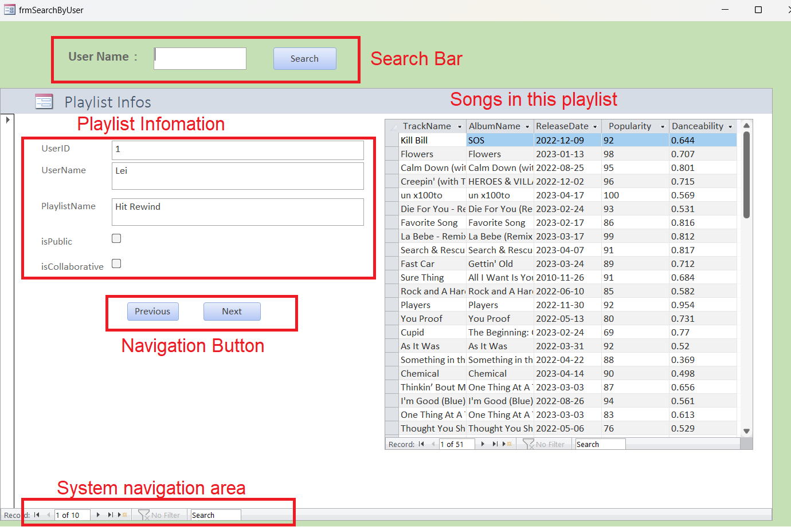

### Playlist Manipulation

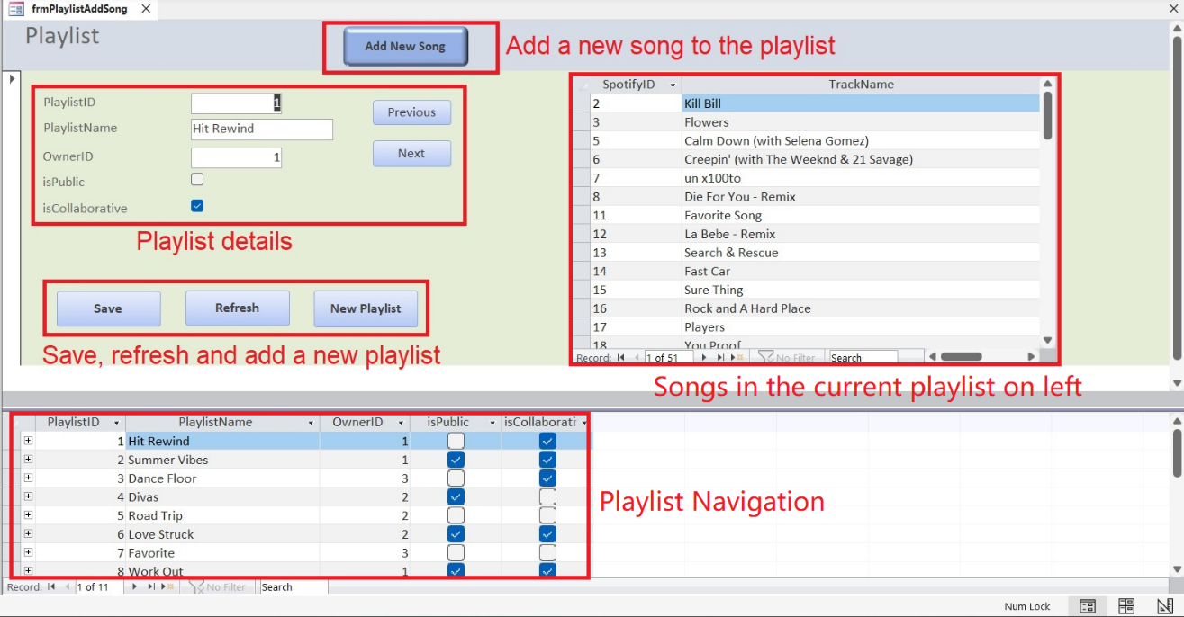**Function description:** This page allows the user to view the details of the playlist, add a new playlist and go to a new page to add songs to playlists.

**Usage:** You can click "Add New Song" and go to the new page to add new song information. The songs of the playlist are displayed next to the playlist information. In the page, 5 buttons are set to realize the 5 operations of previous, next, save, refresh, and new playlist respectively. On bottom, all playlists are presented and users can choose the one they are interested directly.

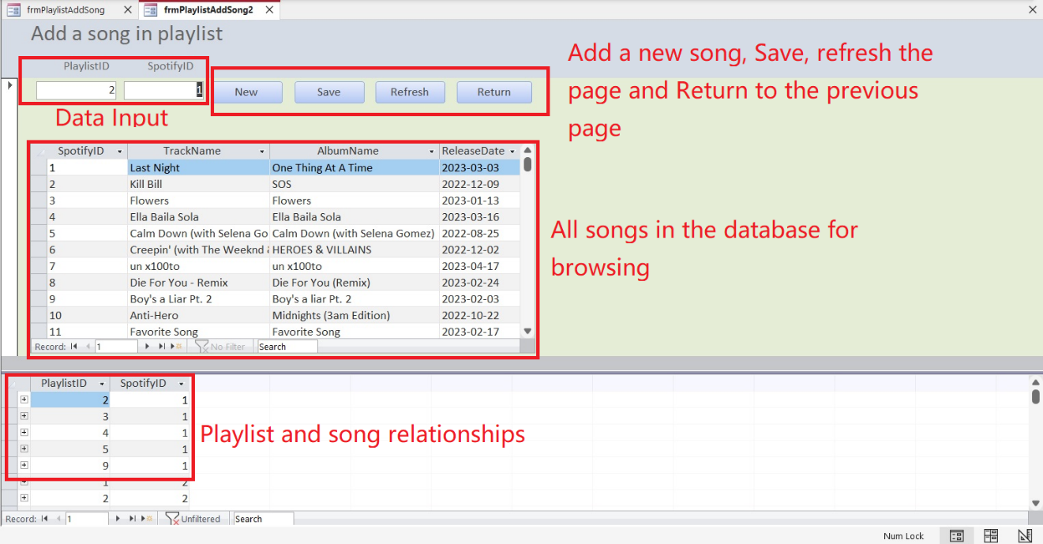**Function description:** This is the second page of the previous form, through this interface, you can add songs to the playlist.

**Usage:** Add a new song to the playlist by clicking on New, then save and refresh. Click on Return to go back to the previous page or close this one.

### Search By Artists

**Function description:** This interface allows you to query the information of artist and their work by entering their name.

**Usage:** Enter artist name in the text box and click the "Search" button to complete the query. You can see the information about the artist and the related music in the forms below.

### Search By Song

**Function description:** View music information by searching track name.

**Usage:** Enter the track name in the text box and click the Search button to complete the query. You can see the information of the artist's name and the genre name in the 2 forms below.

### Dancing Song

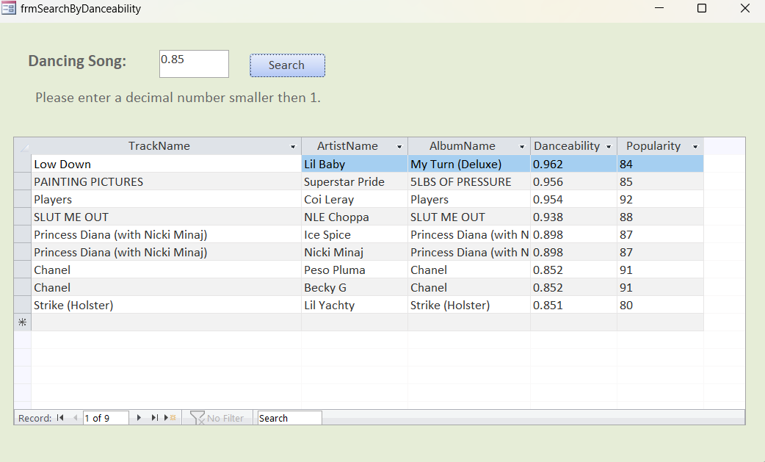

**Function description:** Search song information by danceability (value 0 to 1).

**Usage:** Enter the search criteria in the text box and click "Search" to complete the query. You can view the information you need in the form below.

### Popularity

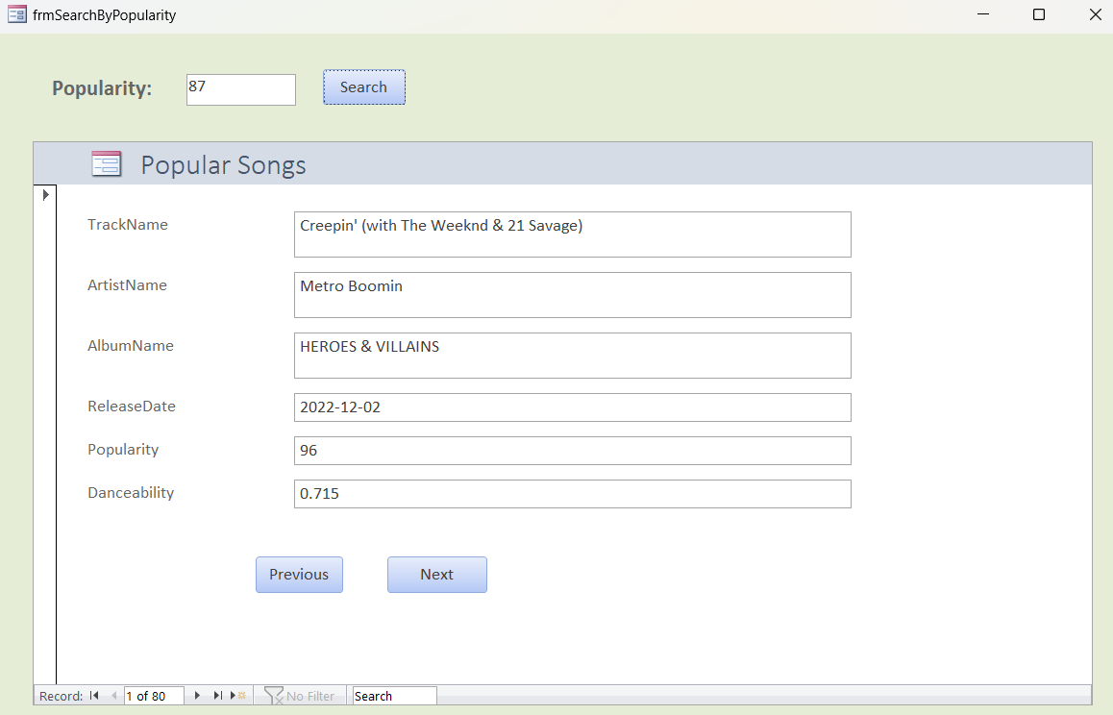

**Function description:** Search for music information by their popularity (value 0 to 100).

**Usage:** Enter the value you want to search in the text box, then click the search button to complete the search, you can see one unique record in the table below, and you can use the previous and next buttons to search for other records with the same required criteria.

### Basic forms

There are 8 basic forms named starting with dbo: dbo_artists, dbo_users, dbo_songs, etc. These forms are made directly by the data tables, and they are designed for data input. With these forms, users can update their Spotify music database. These forms share the same functionality and structure:

* Artist Info Section: Navigate artist data by records, you can go to next, previous record, make a new record and save.
* Artist Navigation Section: Navigate all records of artists, use scroll bar to browse.
* If you want to delete a record, select the record in the datasheet below and press delete key on your keyboard.
* The delete button is not included in the Data and Navigation Area is for avoiding unintentional deletion.

#### Artists

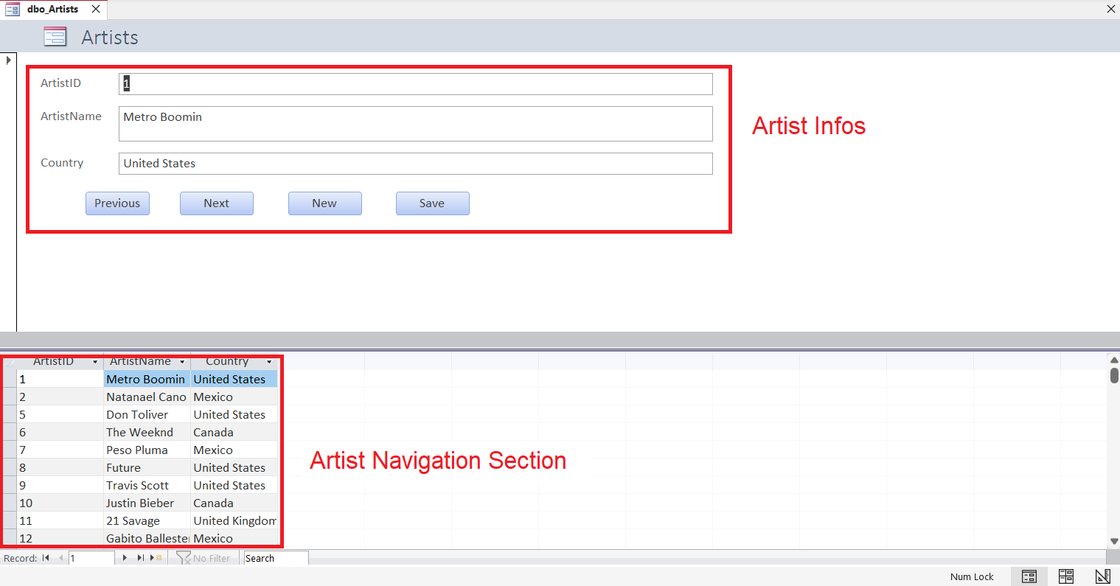

**Function description:** Through this interface, users can add the ID, name, country information of artists.

**Usage:** Click on Previous or Next to go to other records, New to create a new record and Save to save.

#### Artists and Songs

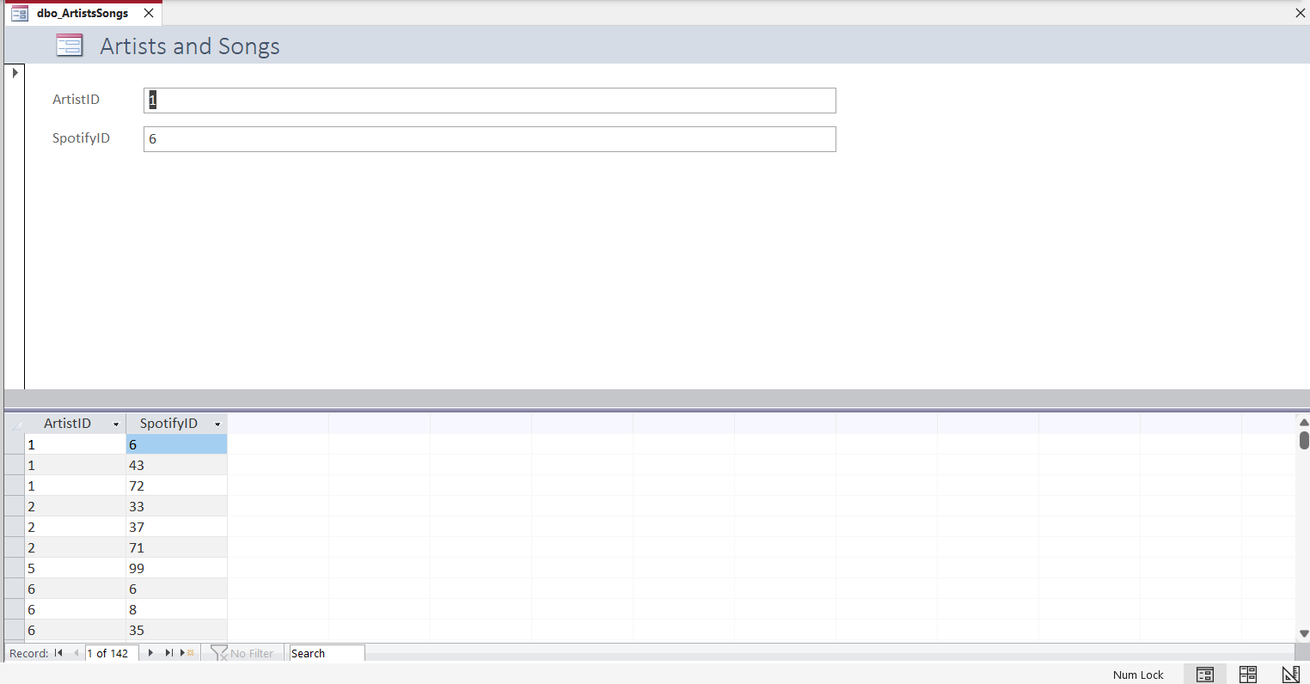

**Function description:** According to the AiristID, you can find the corresponding SpotifyID.

**Usage:** Click on the datasheet section to select and operate on the records.

#### Genres

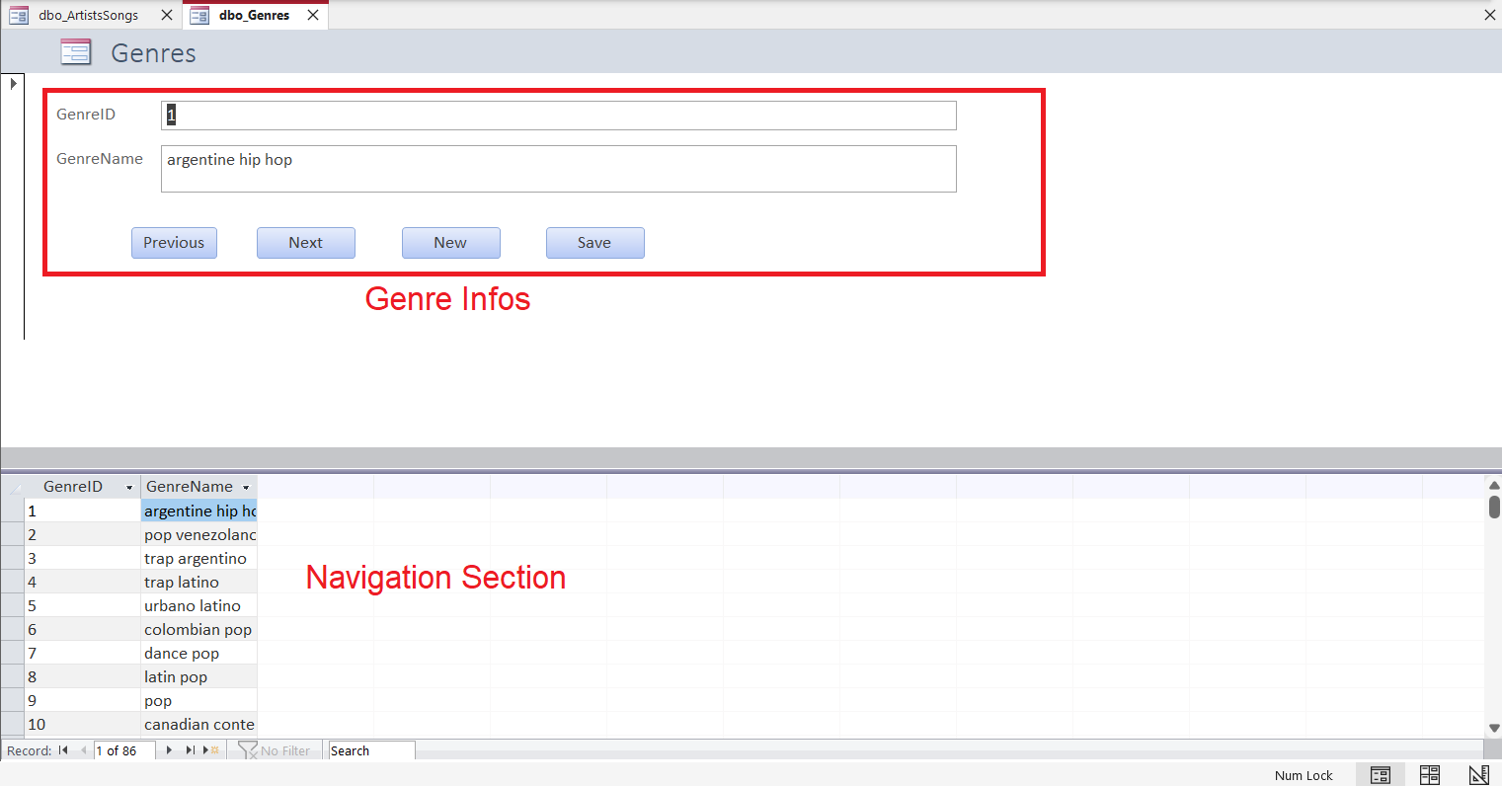

**Function description:** This interface allows you to check the different styles of songs.

**Usage:** You can check the name of genre and the corresponding ID through the button, and you can add a new genre through the “new” button and click the save button to save it.

#### Genre Songs

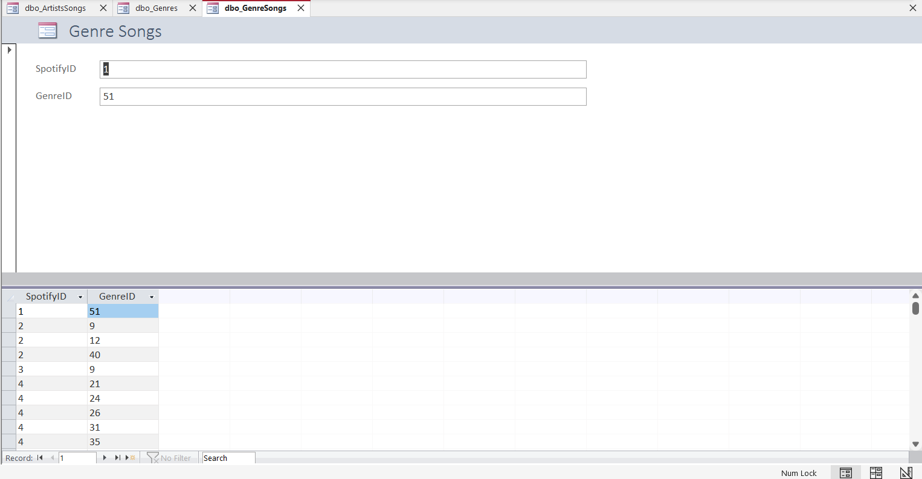

**Function description:** Through this page, you can check the corresponding GenrelD by SpotifyID.

**Usage:** Click on the datasheet section to select and operate on the records.

#### Playlists

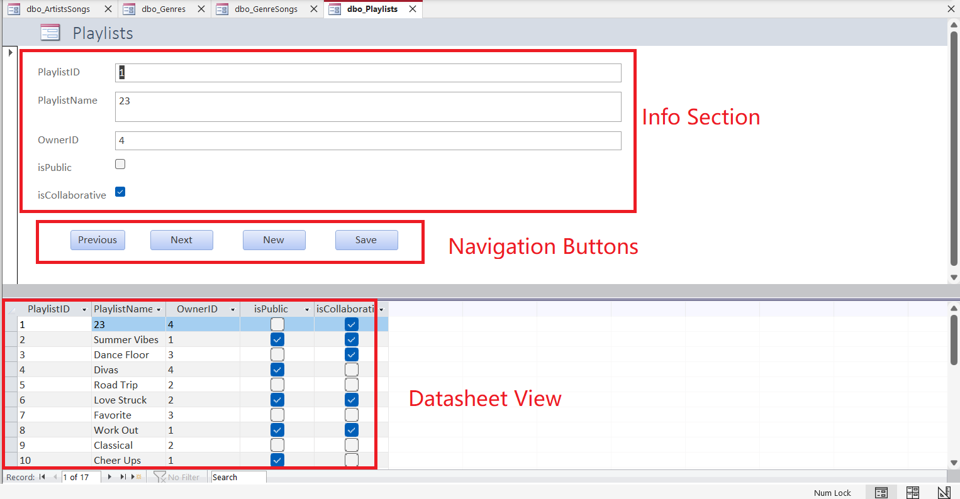

**Function description:** View playlist information, names, owner IDs and status.

**Usage:** Click on Previous or Next to browse, New to create a new record and Save to save. All playlists presented in the lower datasheet section allow users to find a interested playlist easily.

#### Song and Playlists

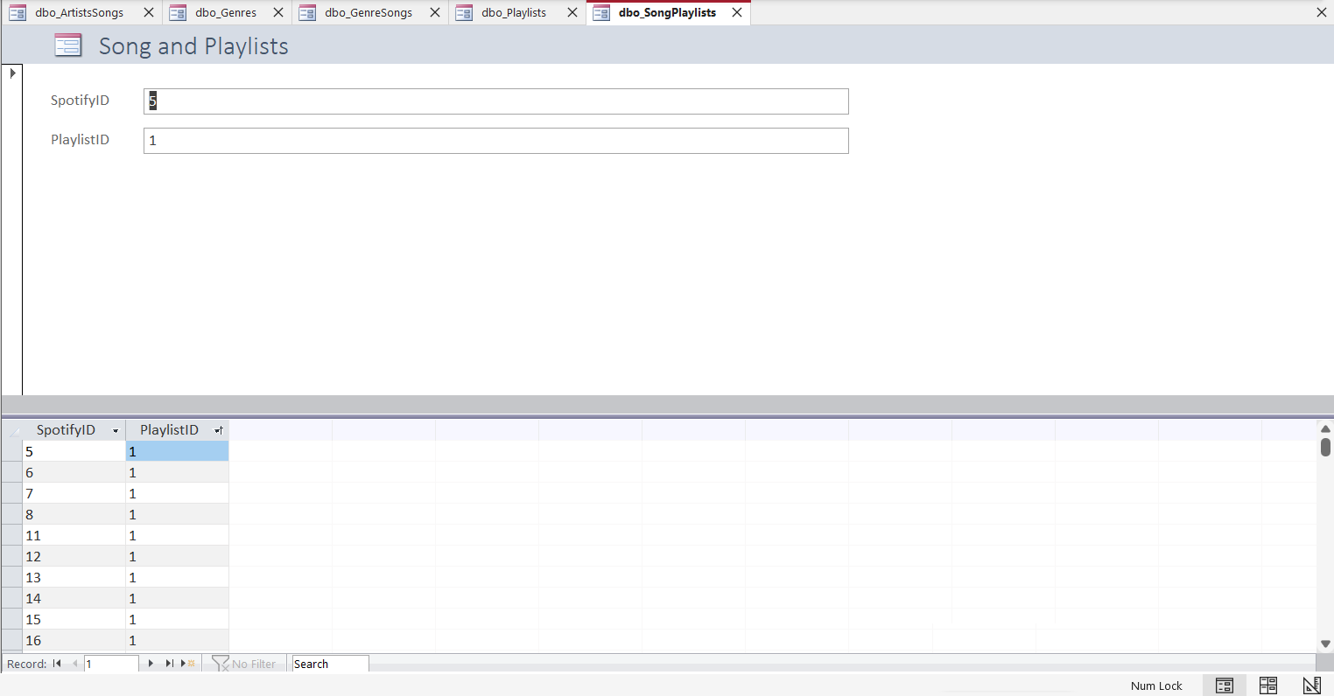

**Function description:** According to SpotifyID, you can find the corresponding PlaylistID.

**Usage:** Click on the datasheet section to select and operate on the records.

### Songs

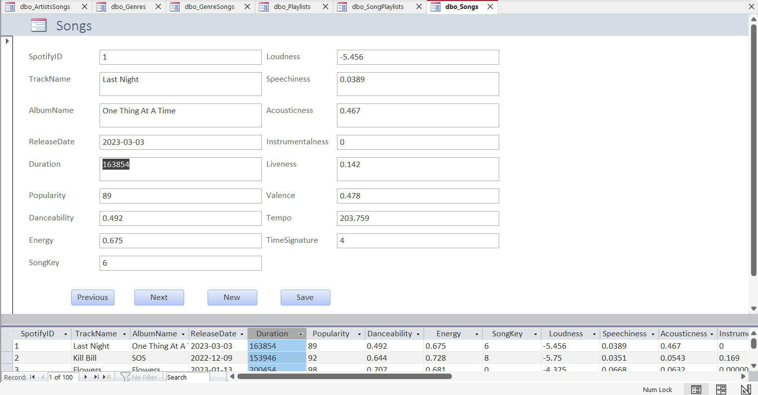

**Function description:** In this interface, you can find detailed information about all songs.

**Usage:** In this page, four buttons are set to PREVIOUS, NEXT, NEW and SAVE, which allow users to perform simple data retrieval and addition work.

### Users

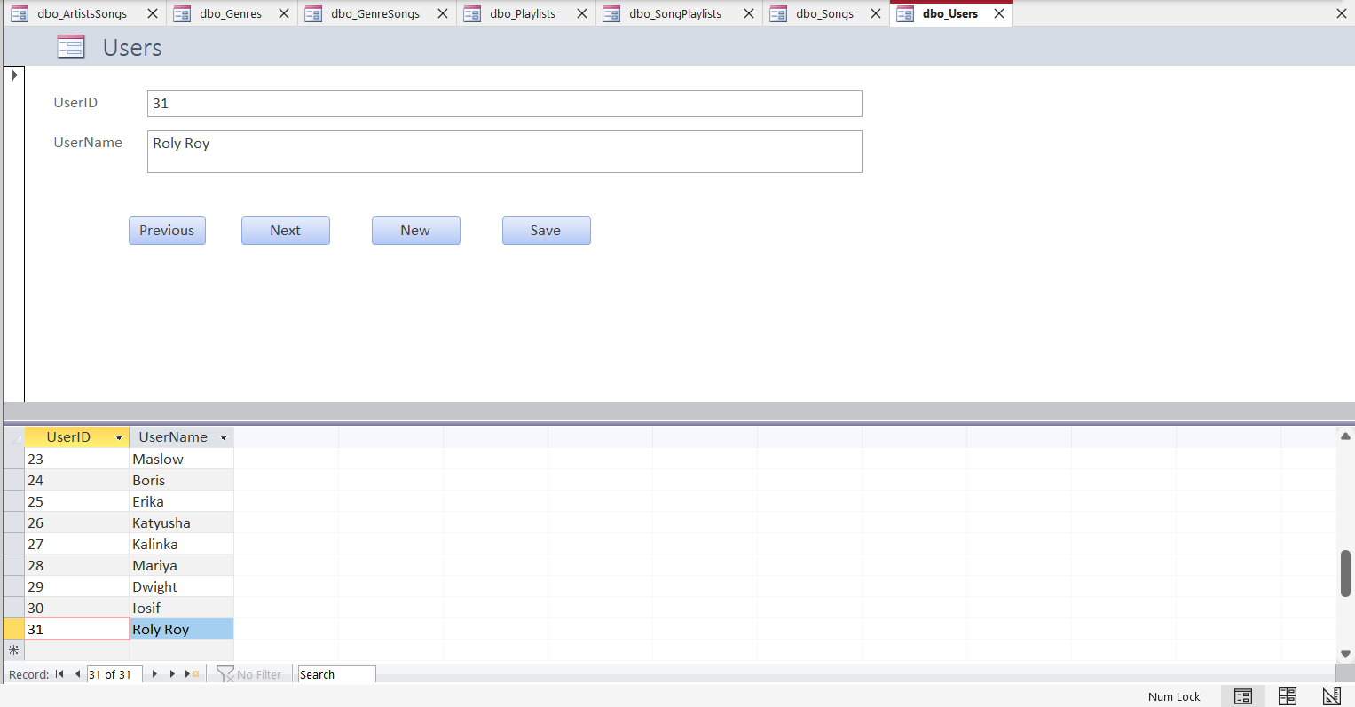

**Function description:** This form shows the user ID and name.

**Usage:** You can use the buttons to perform the desired operation, such as adding a new user and sav.

### Atrists and songs report

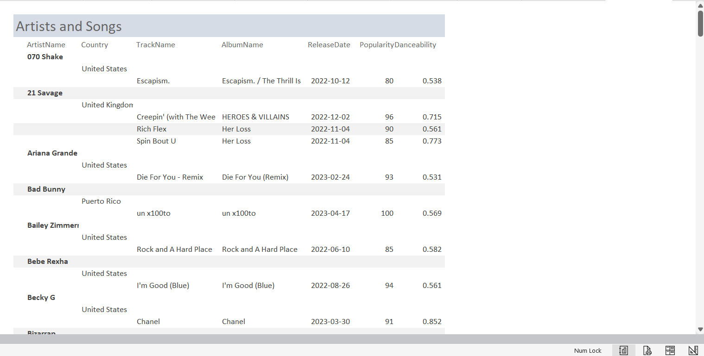

**Function description:** display artist information; their name and country, as well as basic information of songs they have produced.

**Usage:** observe, analyze artists’ information accompanied by songs’ information.

### Song details report

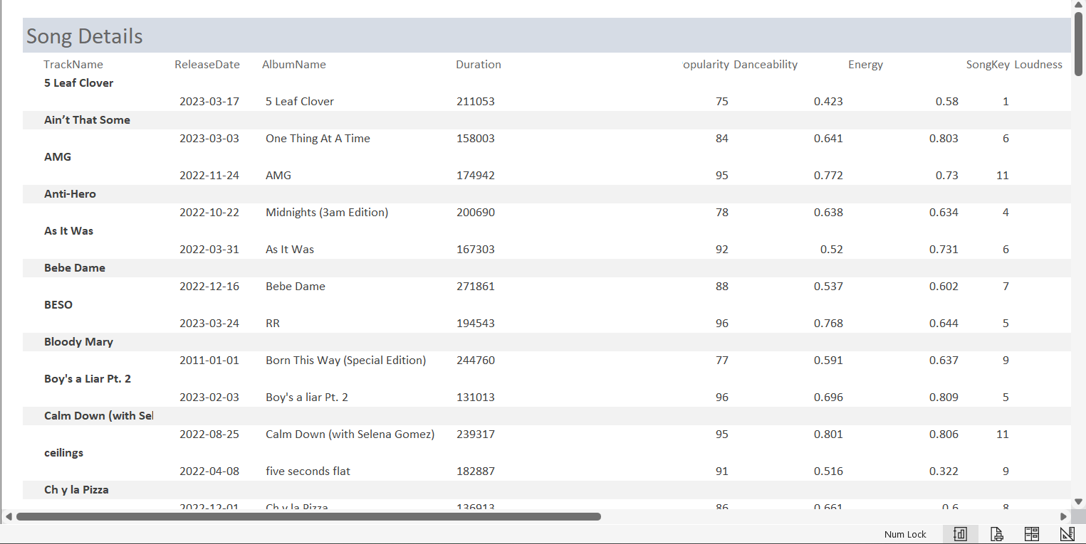

**Function description:** Display song information. Fields include the track name, release date, album name, duration in milliseconds, popularity, danceability, energy, song key, loudness, and many others.

**Usage:** to view the variety of Spotify song data that that are used behind the scenes for the benefit of the user to have personalized song recommendations.

### Songs and Genres report

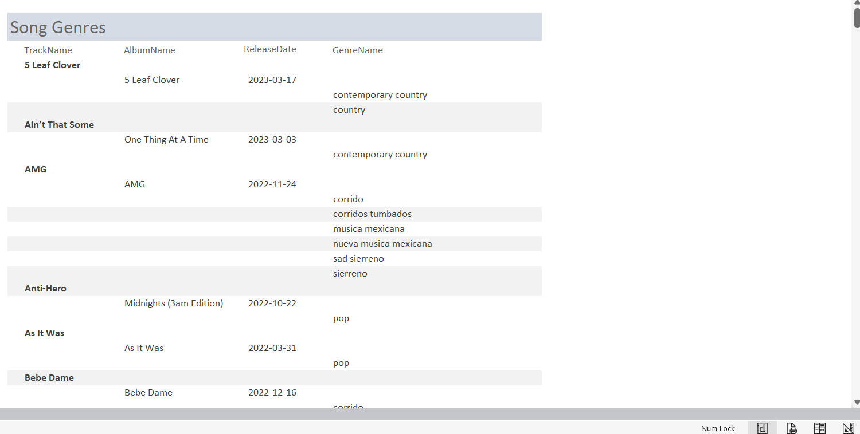

**Function description:** Highlight song basic information and genres of songs.

**Usage:** View the genres each song is linked to.

### Users and details report

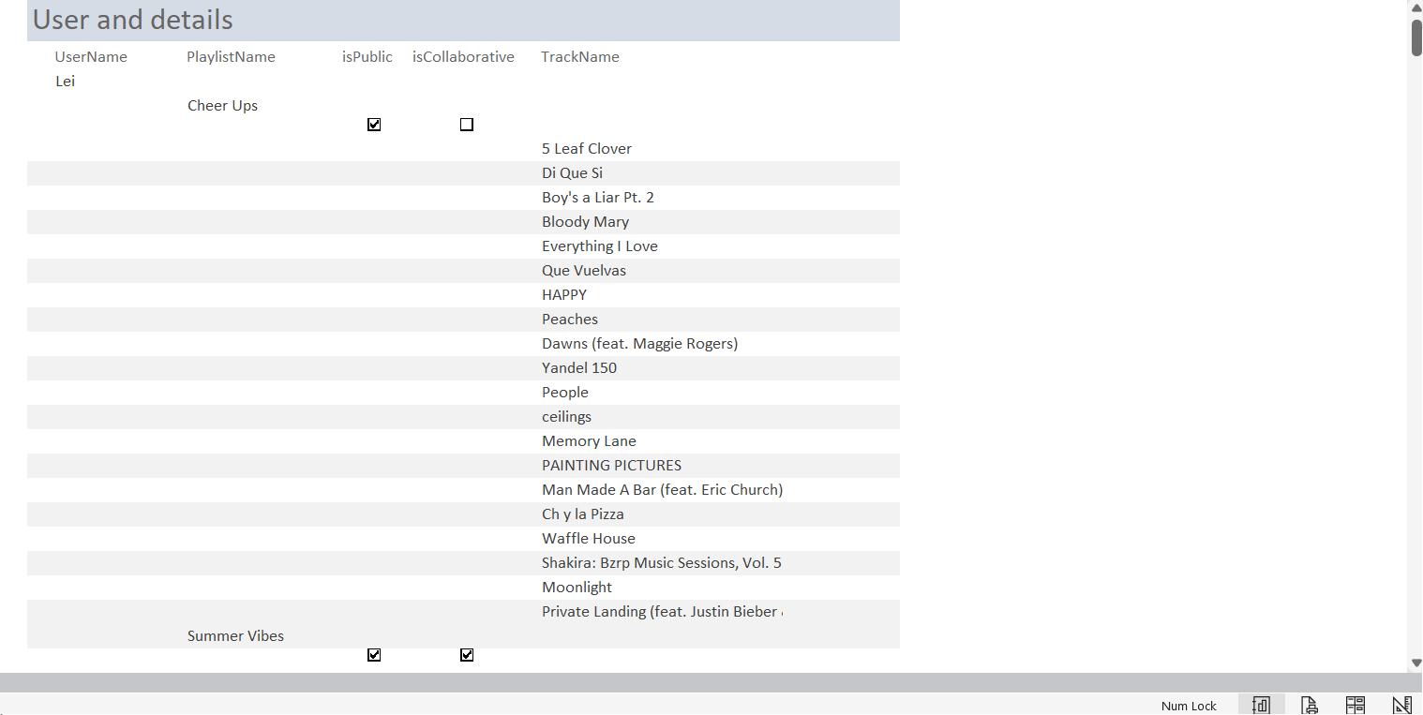

**Function description:** Show all users, their playlists and songs.

**Usage:** view all available users and more by a hierarchy structure.

## Back-end Users

As a back-end user, you play a critical role in managing the server-side components of the Microsoft Access application. Your responsibilities include configuring and maintaining the database server, ensuring data integrity, managing security permissions, and optimizing performance. You'll work with the back-end infrastructure, such as the server, database engine, and data storage, to ensure smooth operation and reliable data management. With your expertise, you enable seamless communication between the front-end interface and the underlying database, empowering front-end users to interact with the application effortlessly.

The form design, report design and query design of Access play a key role in all perspectives of using this application. This instruction will guide you to make a form, a report combining a query.

### Making a search form

* Go to Create then Form Design, then add a new text box in the empty screen and save.

* Go to Create then Query Design, add a table or tables you want to retrieve data from, double click the attributes. Go to the attribute you want to search in the form, right-click the criteria and build.

* Go to your application file, Forms, All forms, select the one you just created, select the text box you just created and double click, or directly enter the corresponding information by their names in the text area.

* Go back to the form design view, go to Property Sheet, select Form, Data, Record Source, select query you just create, link the form and the query.

* Select the query you just created first, go to Create, Form, and enter the search criteria as required, you will create a sub form for this query, save and close.

* Open the design view of the form again, go to the tools bar on top of Access window and add a sub form on your page. In the SubForm Wizard, choose the sub form you just made and finish.

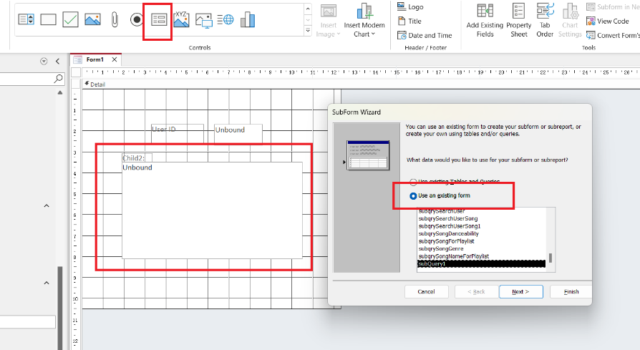

* Add a new button on your page, select Form Operation and Refresh Form Data. Save and reopen the form in Form View, you will see the search form you just created.

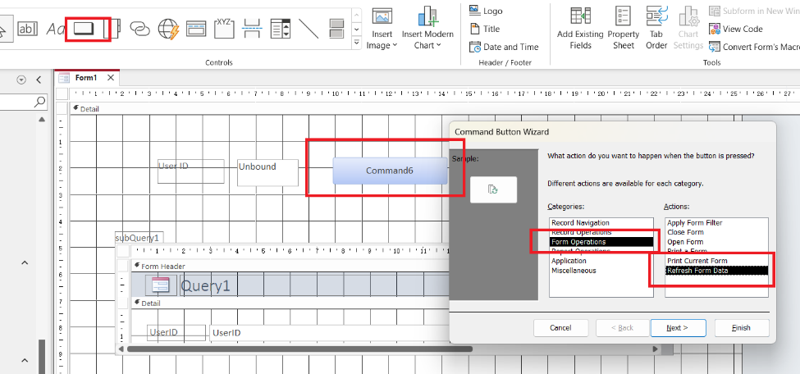

### Making a report by Report Wizard

* 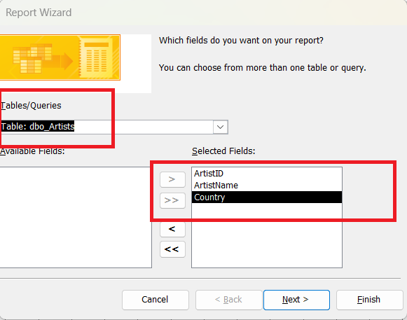A screenshot of a computer

  Description automatically generated with medium confidenceGo to Create then Report Wizard, choose the tables you want to work with and put the attributes you want to show on the report to the Selected Fields area.
* 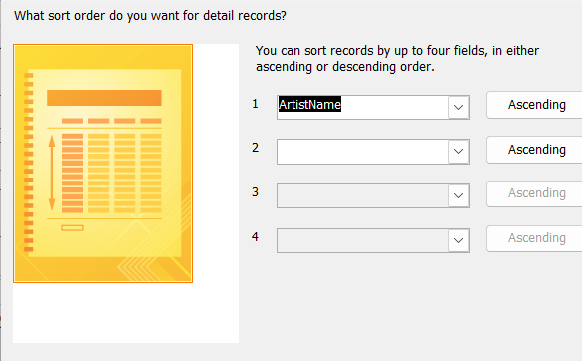Choose the grouping attributes, ordering attributes, layout, orientation and other characteristics, then you will get a report with the information you selected.

Microsoft Access is very powerful in application level; it helps us with the interface design. There are much more functions for us to explore. This assignment gave us a chance to get a general knowledge about Access as well as SQL Server.